Title, Times New Roman 14 Bold, Capitalize Each Word

# Author One1*, Author Two1, Author Three2

#### City, State, Country

*Corresponding Author: Provide name and email address

**Abstract**

Every manuscript should include an abstract that has a single paragraph with less than 250 words. Do not include tables, figures, and citations. The abstract may include the research topic, research question/hypothesis, methodology, main findings, and conclusions.

*Keywords: Provide 3 - 7 Keywords, Keyword1, Keyword2, Keyword3*

**Title, Times New Roman 12 Bold**

1. **Introduction (Heading 1; Use this style for heading 1)**

This template shows instructions to prepare the manuscript. The component of the paper includes Abstract, Introduction, Materials and Methods, Results, Discussion, Conclusion, and References. US English is the official language of the Journal of Academic Inquiry and Knowledge.

0.25-inch indentation for all content. One space between each heading and the first sentence. No space between paragraphs.

The author discusses current and previous related works performed by other researchers. In addition, the introduction shall include an overview of the research topic, the significance of the research, the research problem, the hypothesis, relevant literature highlighting the need for the current study, and provide a clear statement of purpose and objectives of the research.

* 1. Abbreviation (Use this style for heading 2)

Make the expanded form of an abbreviation for the first use, and immediately after, provide the abbreviation in parenthesis.

*Page Setup (Use this style for heading 3)*

The 1-inch margin for all sides, top and bottom (normal in MS WORD margin). The body text font is Times New Roman with a size of 12 and is double-spaced.

1. **Materials and Methods**

This section is for experimental setups and procedures. All descriptions should be detailed enough for other researchers to follow the procedures. This section should be descriptive, and no bullet/number formats are accepted. The section should include the research design including participants, materials, and the procedure. Clearly explain any variables and measures used in the study. Include details about data collection and analysis methods employed.

1. **Results**

This section shows experimental data, measurements, and observations. No explanations or interpretations are expected in this section. Any interpretation should be addressed in the discussion section. All tables, figures, and equations should be located in the proper positions and presented in a clear and concise manner. Provide a written explanation of the statistical analysis and results.

* 1. Table

The table caption should be located right above the table with a left alignment. NO image file can be used as a table. The table needs to be created using the MS WORD table drawing function or similar tools.

* 1. Equation

To create an equation, use MS WORD equation editor or similar tools (such as MathType and GoogleDoc equation ). Discourage drawing equations. The equation located in the middle and below is a sample.

|  |  |  |
| --- | --- | --- |
|  |  | (1) |

Where x, y, and z are ….., respectively.

* 1. Figure

The figure should be located in the proper position referred to in the manuscript. All figures should be comprehensible to readers and simple enough to provide clear information related to the research. An example is shown below.

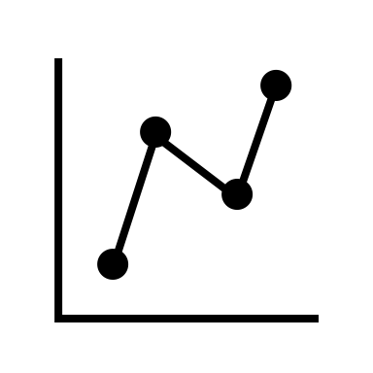

Figure 1. Figure caption should follow the figure and the first letter needs to be capitalized. If you reproduce the third-party published information, you need to disclose the source and obtain permission if needed.

1. **Discussion**

In this section, observed results and data should be interpreted concisely. In addition, the authors need to explain the significance of the research findings and revisit the hypothesis described in the introduction. Discuss the implications of the findings and their significance. Authors can compare the results with previous research and address any inconsistencies. Additionally, the authors can identify the limitations of the study and suggest directions for future research.

1. **Conclusion**

Authors can summarize the main findings and their implications. Restate the research question(s) or hypothesis and discuss if they were supported. Restate important findings throughout the research.

**References**

Follow the guideline as shown here. Citations should be in alphabetical order by last name. If there is no information you can’t find, follow the APA format.

One space between each reference.

In an article, up to two authors, use last name(s) and year in parenthesis. Example: (Doe, 2020), or (Doe and Smith, 2020)

In an article, with three or more authors, use the first author's last name and year in parenthesis. Example; (Doe et al., 2020)

Include DOI information at the end if available.

**Appendices (if applicable)**

Include any supplementary materials such as surveys, data, or interview transcripts.

**Acknowledgment**

This is an optional section and is used to appreciate individuals who support/encourage the research performance.

**Disclosure**

When authors include non-high school students, the advisor should disclose each author’s contribution including research performance and preparation of the manuscript.